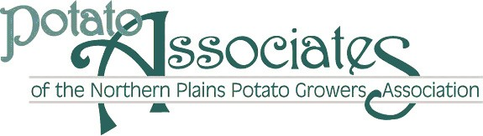

Potato Associate Renewal Dues 2022-23

Dear Potato Associate Member,

Please accept this invoice as an invite to join us in supporting our potato growers in 2022-23. The Potato Associates will do their best to ensure the growers recognize your support of their industry and we will try to spend your dollars wisely. From the 2021 dues, we have supported several potato grower events.

With your dues, you will receive the Valley Potato Grower magazine for the year, the weekly Potato Bytes electronic newsletter and receive invitations to all Northern Plains Potato Growers Association events including the Potato Golf Open, Field Days and the NPPGA Annual Meeting.

Below is a renewal dues form, which is a fillable form, to fill out and return via E-mail. The Potato Associates renewal form can also be found on the NPPGA website under the Potato Associates page at www.nppga.org. Or you could fill this form out and mail it with a check to the address below.

Please select the "Option Rates" listed below. You can also just print the form, fill it out and return by mail.

Please call or e-mail me if you have any questions, and we hope to see you at the Potato Industry functions!
Thank you.
Gary Shields
Potato Associate President

Potato Associate Membership Levels
Individual membership (Annual fee: $50.00)
Corporate membership (Annual fee: $200.00) list up to six names below. Additional members ($30 each additional member for seven or more)
For Corporate membership only

First name Last name

Company Name

Street address Street address line 2

City State Zip code

Cell number Work number

E-mail

Payment by Credit Card

Amount to process on credit card Credit card number

Credit card expiration date Security code (back of credit card) CC Billing ZIP CODE

Corporate Membership on next page

Corporate Membership ($200 up to six names - $30 each additional after the six names)
Additional colleagues covered under corporate membership (list up to five additional names)
Name E-mail address Cell #

Name E-mail address Cell #

Name E-mail address Cell #

Name E-mail address Cell #

Name E-mail address Cell #

Name E-mail address Cell #

Name E-mail address Cell #

Name E-mail address Cell #

Name E-mail address Cell #

Name E-mail address Cell #

Duration of membership
From July 1, 2022 to June 30, 2023
Potato Associate memberships are renewed annually.

Send your check payment by mail ~ payable to the Potato Associates to PO Box 301, East Grand Forks, MN 56721

